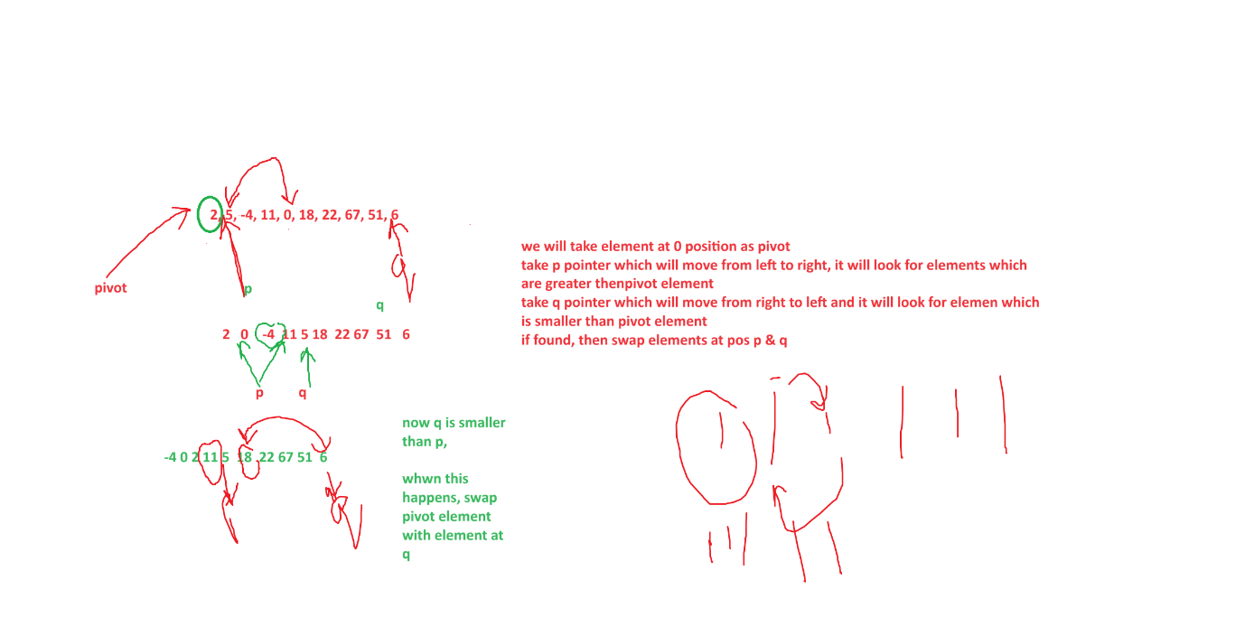

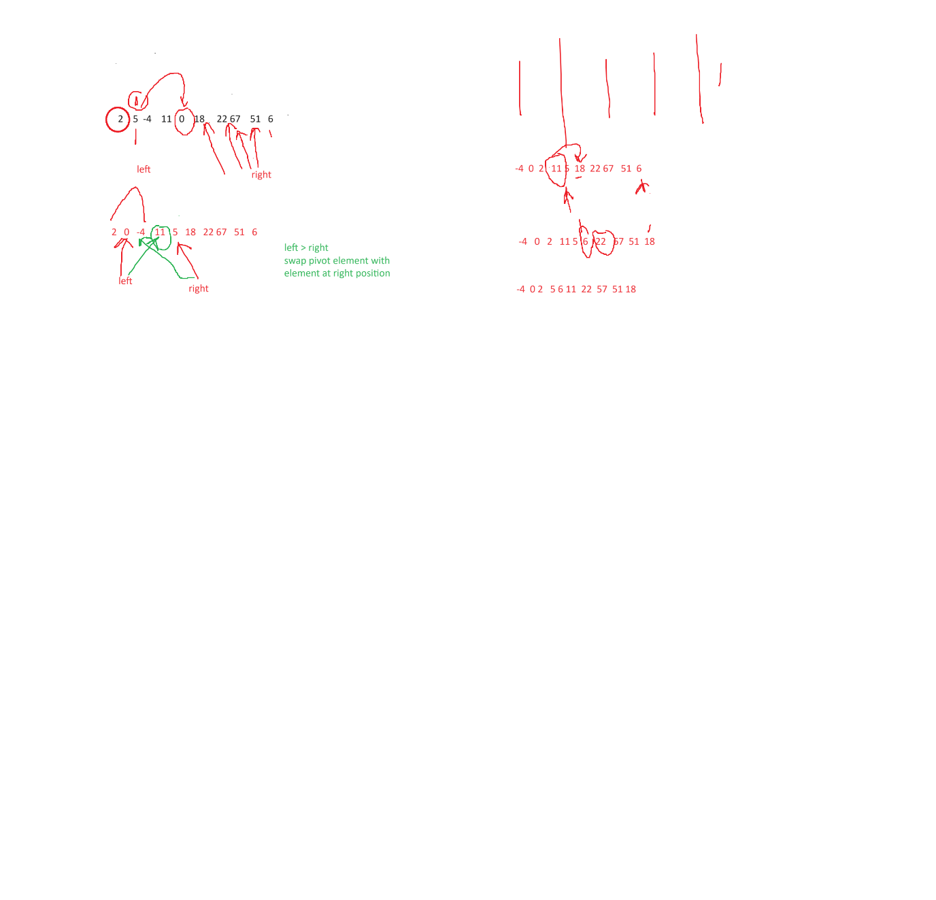

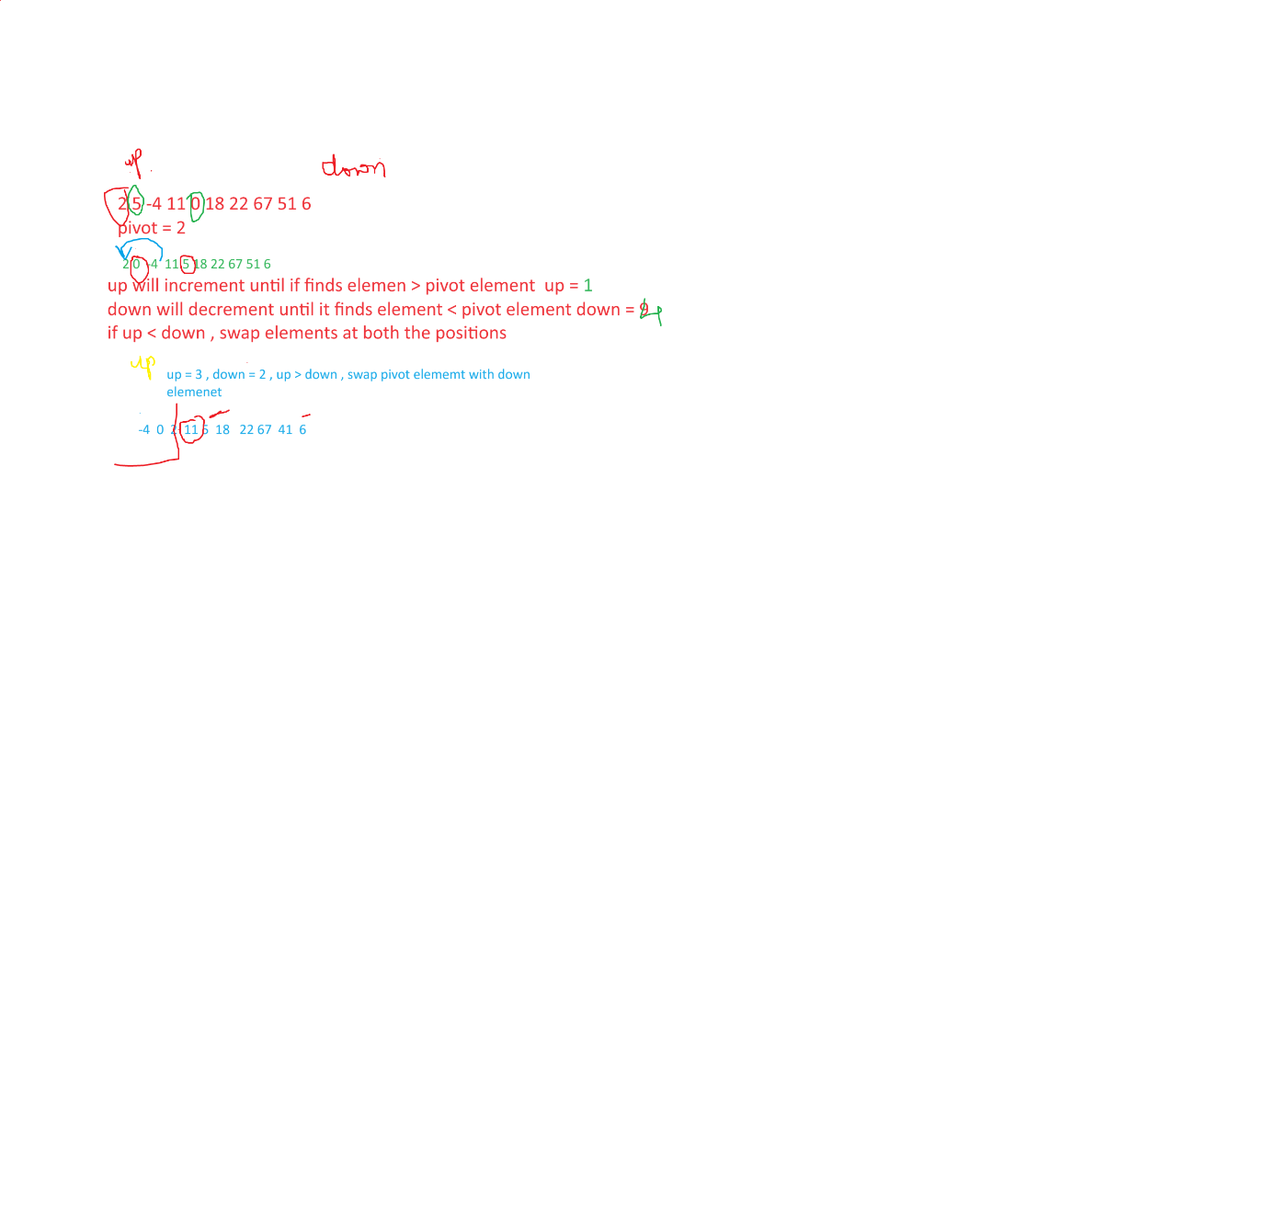

using System;

using System.Collections.Generic;

using System.Linq;

using System.Text;

class Program

{

static void Main(string[] args)

{

int[] arr = new int[] { 2, 5, -4, 11, 0, 18, 22, 67, 51, 6 };

Console.WriteLine("Original array : ");

foreach (var item in arr)

{

Console.Write(" " + item);

}

Console.WriteLine("After Sorting array : ");

QuickSort(arr, 0, arr.Length-1);

foreach (var item in arr)

{

Console.Write(" " + item);

}

}

static void QuickSort(int[] arr, int left, int right)

{

// check if elements are to be sort

if (left < right)

{

// find the pivot

int pivot = Partition(arr, left, right);

if (pivot > 1)

{

QuickSort(arr, left, pivot - 1);

}

if (pivot + 1 < right)

{

QuickSort(arr, pivot + 1, right);

}

}

}

static int Partition(int[] arr, int left, int right)

{

// select the pivot element

int pivot = arr[left];

// continue until left and right positions meet

while (true)

{// move left pointer towards right side until

// we find element bigger than pivot element

while (arr[left] < pivot)

{

left++;

}

while (arr[right] > pivot)

{

right--;

}

// if left pointer is smaller than right. swap both of them

if (left < right)

{

if (arr[left] == arr[right]) return right;

int temp = arr[left];

arr[left] = arr[right];

arr[right] = temp;

}

else

// return the right position

return right;

}

}

}